Polish 1st Armored Division
44
MILITARY

1ST CAN
AIR POWER
Jabos: +1 1st CAN
RESOURCES
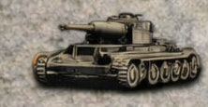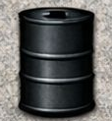
1 x Kampfgruppe* Lose 1

*Deploy to map or Strategic Reserve for 1 action

ORDERS: 3 Actions
+1 Defense Value 1st CAN
+1 Model

The First Polish armored division was attached to the First Canadian Army. It entered combat on August 8 during Operation Totalize. The division twice suffered serious bombings by Allied aircraft yet it achieved a victory against the Wehrmacht in the battles for Mont Ormel and the town of Chambois. Maczek's division had the crucial role of closing the pocket at the escape route of those German divisions, hence the fighting was absolutely desperate.

